**16.****USING RAPTOR –ARMSTRONG NUMBER OR NOT**

**Y.NAVEEN KUMAR REDDY**

**192111405**

**FLOWCHART:**

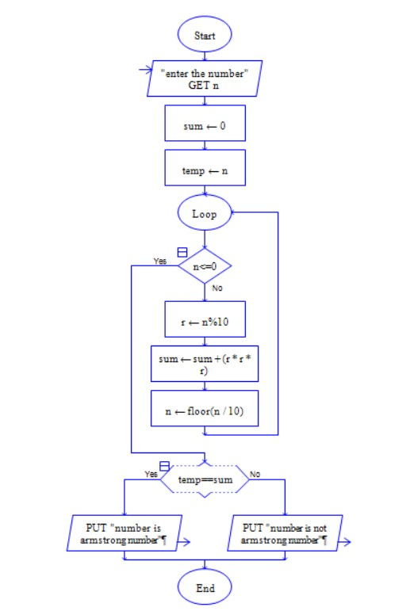

**OUTPUT:**

INPUT: 371

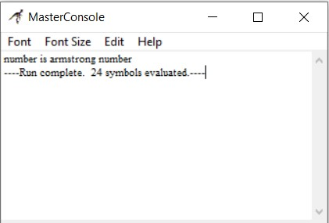

**RESULT:**

The program is executed and verified successfully.